**Output for the XML Extraction:**

**Screen shots:**

**Time**

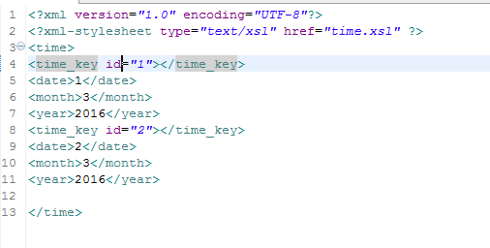

**Before inserting:**

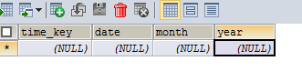

**After inserting:**

